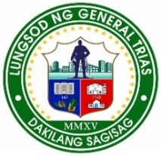



Province of Cavite Region IV-A CALABARZON
City of General Trias
BARANGAY PANUNGYANAN
OFFICE OF THE PUNONG BARANGAY
CERTIFICATE OF INDIGENCY


TO WHOM IT MAY CONCERN:
This is to certify that __________________________of legal age single ( ) married ( ), widow/er ( ), Filipino is a bonafied resident of PUROK ___, Barangay Panungyanan City of General Trias, Cavite.

Further certify that he/she is one among our residents that can be considered as”indigent”. The collective family income is not even sufficient to support all their needs.
This certification is being issued upon request of MR./MS./MRS.______________ for the following purposes.
( ) Financial/Medical Assistance ( ) Burial Assistance
( ) Senior Citizen Social Pension ( ) Vaccination Requirements
( ) Educational Assistance ( ) Other’s

Issued this ____ day of _________ 2025 , at Barangay Panungyanan, City of General Trias, Cavite.

Attested by:

JEREMIAH-ANGELICA B. CAHINHINAN
Barangay Secretary
Approved by:

RENATO S. ALMANZOR
Punong Barangay
Note: Not valid without official seal/erasure.

